Name: Ali Aoun
Class: BSSE 2C
Roll No: 131
Problem 1:
A data analyst is studying a list of numbers and wants to know how many of them are even. To keep the program organized, the counting should be done using a function.
#include <iostream>
using namespace std;

int countEvenNumbers(int arr[], int size)
{
int count = 0;

for (int i = 0; i < size; i++)
{
if (arr[i] % 2 == 0)
{
count++;
}
}

return count;
}

int countOddNumbers(int arr[], int size)
{
int count = 0;

for (int i = 0; i < size; i++)
{
if (arr[i] % 2 != 0)
{
count++;
}
}

return count;
}

int main()
{
int arraySize;

cout << "Enter Size of Array: ";
cin >> arraySize;

int numbers[arraySize];

for (int i = 0; i < arraySize; i++)
{
cout << "Enter value in index " << i << ": ";
cin >> numbers[i];
}

int evenCount = countEvenNumbers(numbers, arraySize);
int oddCount = countOddNumbers(numbers, arraySize);

cout << "Number of Even Numbers in Array: " << evenCount << endl;
cout << "Number of Odd Numbers in Array: " << oddCount << endl;

return 0;
}
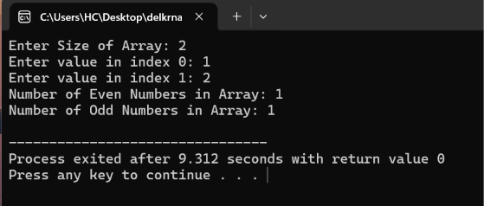

correct completion:
int countEvenNumbers(int arr[], int size)
{
int count = 0;

for(int i = 0; i < size; i++)
{
if(arr[i] % 2 == 0)
{
count++;
}
}

return count;
}
Problem 2:
A school administrator wants to create a digital seating chart for a classroom. The classroom has R rows and C columns of desks. Each desk contains a student's roll number. The administrator needs a program to store and display the seating arrangement.
#include <iostream>
using namespace std;

int main()
{
int rows, columns;

cout << "Enter Rows: ";
cin >> rows;

cout << "Enter Columns: ";
cin >> columns;

int seatingChart[rows][columns];

cout << "Enter Roll Numbers:" << endl;

for (int i = 0; i < rows; i++)
{
for (int j = 0; j < columns; j++)
{
cin >> seatingChart[i][j];
}
}

cout << "Seating Chart:" << endl;

for (int i = 0; i < rows; i++)
{
for (int j = 0; j < columns; j++)
{
cout << seatingChart[i][j] << " ";
}
cout << endl;
}

return 0;
}
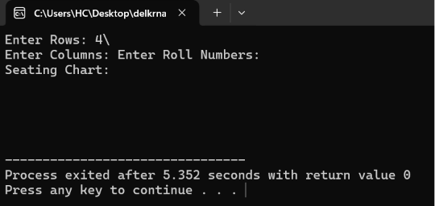
Problem 3:
A mathematics application needs to calculate the Greatest Common Divisor (GCD) of two numbers. To keep the logic separate from the main program, the developer has created a function named find GCD.
#include <iostream>
using namespace std;

int findGCD(int a, int b)
{
while (b != 0)
{
int temp = b;
b = a % b;
a = temp;
}

return a;
}

int main()
{
cout << findGCD(48, 18);

return 0;
}
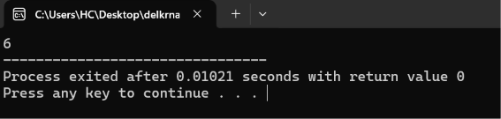
Correct completion:
int findGCD(int a, int b)
{
while (b != 0)
{
int temp = b;
b = a % b;
a = temp;
}

return a;
}
Problem 4:
A sports analyst needs a module to calculate the batting strike rate of a player (like Babar Azam) during a tournament.
#include <iostream>
using namespace std;

double calculateStrikeRate(int runs, int balls)
{
return (static_cast<double>(runs) / balls) * 100;
}

int main()
{
int runs, balls;

cout << "Enter Runs and Balls: ";
cin >> runs >> balls;

double strikeRate = calculateStrikeRate(runs, balls);

cout << "Strike Rate: " << strikeRate;

return 0;
}
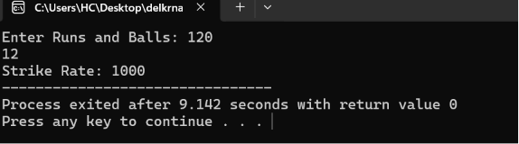
Problem 5:
A text-processing application needs to determine the length of a character array (string). To keep the logic separate from the main program, the developer has created a function named getLength.
#include <iostream>
using namespace std;

int getLength(char arr[])
{
int length = 0;

for (int i = 0; arr[i] != '\0'; i++)
{
length++;
}

return length;
}

int main()
{
char name[] = "Student";

cout << getLength(name);

return 0;
}
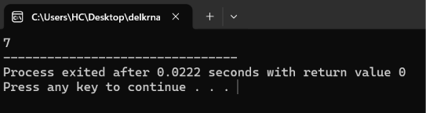
Correct completion:
int getLength(char arr[])
{
int length = 0;

for (int i = 0; arr[i] != '\0'; i++)
{
length++;
}

return length;
}
Problem 6:
A file management application needs to create a copy of a word stored in a character array. To keep the logic separate from the main program, the developer has created a function named copyWord.
#include <iostream>
using namespace std;

void copyWord(char src[], char dest[], int length)
{
for (int i = 0; i < length; i++)
{
dest[i] = src[i];
}

dest[length] = '\0';
}

int main()
{
char original[] = "Code";
char backup[10];

copyWord(original, backup, 4);

cout << backup;

return 0;
}
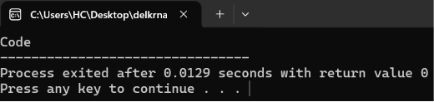
Correct completion:
void copyWord(char src[], char dest[], int length)
{
for (int i = 0; i < length; i++)
{
dest[i] = src[i];
}

dest[length] = '\0';
}

